**Data Catalog**

**Prototypes**

***Qing Gong***

***November 2017***

|  |  |  |  |
| --- | --- | --- | --- |
| **Version** | **Author** | **Date** | **Note** |
| 0.1 | Qing Gong | 2017.10.23 | draft |
| 0.2 | Qing Gong | 2017.11.06 | Changed Division to Organization  Added Version, Author, Head of organization, Help Desk info  Modified field names |
|  |  |  |  |
|  |  |  |  |
|  |  |  |  |

Table of Contents

Wireframes

Front Page

Create Organization

View Organization

View Organization - Datasets Tab

View Organization - About Tab

View Organization - Activity Stream Tab

Create Dataset That is Health Information Subsystem

Create Dataset That is Not Health Information Subsystem

View Dataset That is HIS Subsystem

View Dataset That is Not HIS Subsystem

User Roles and Access Control

## Wireframes

### Front Page

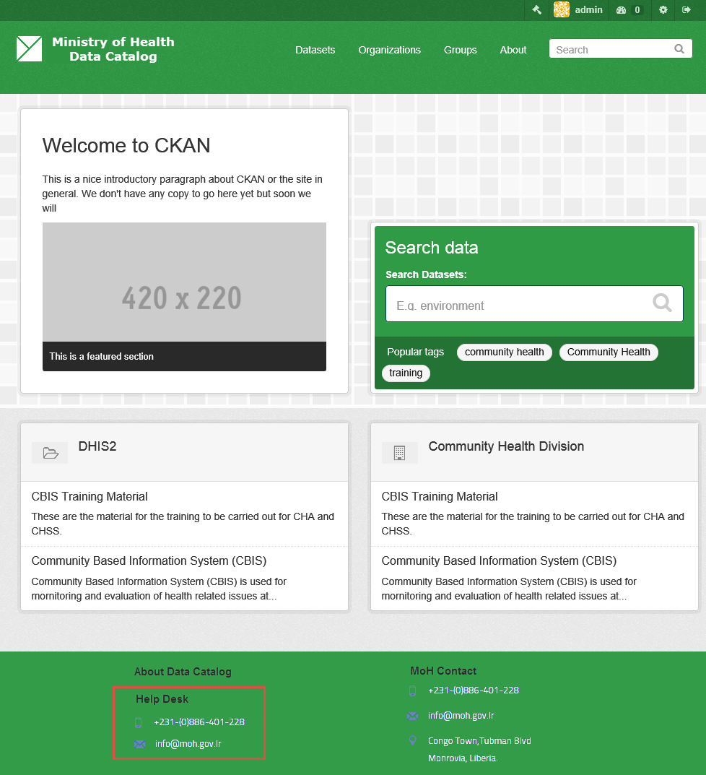

### Create Organization

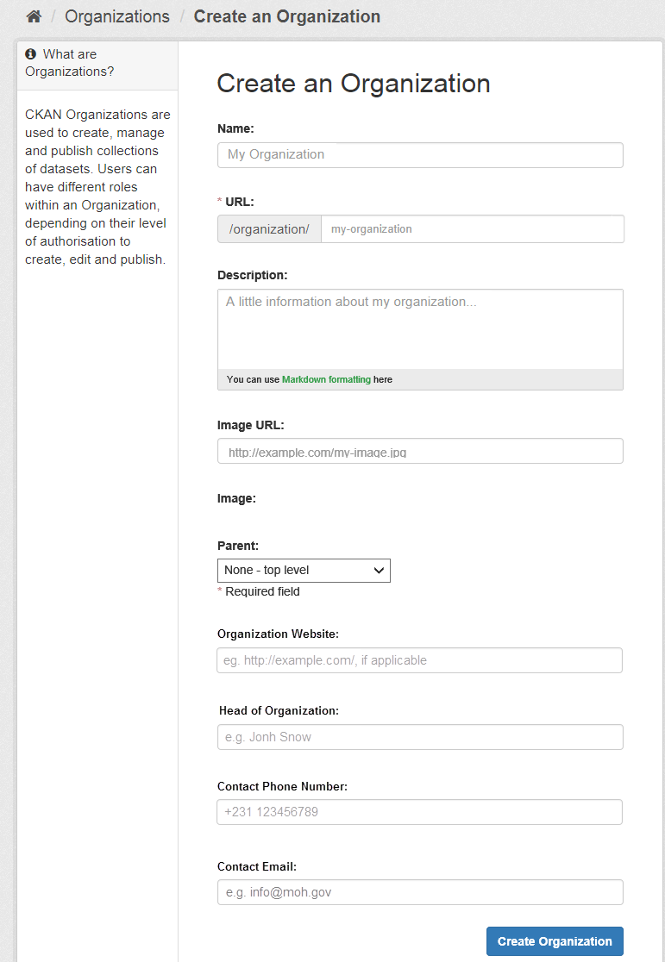

### View Organization

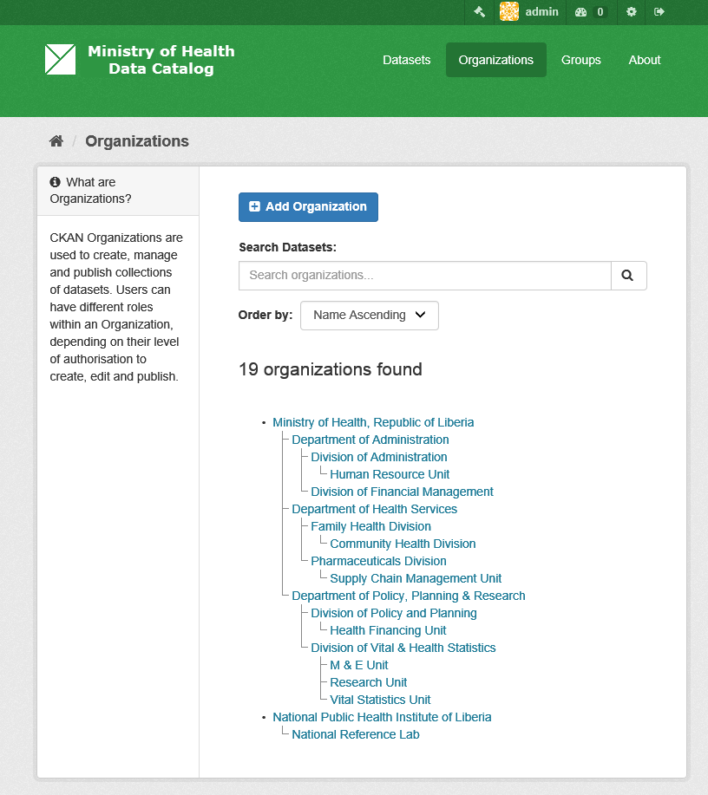

### View Organization - Datasets Tab

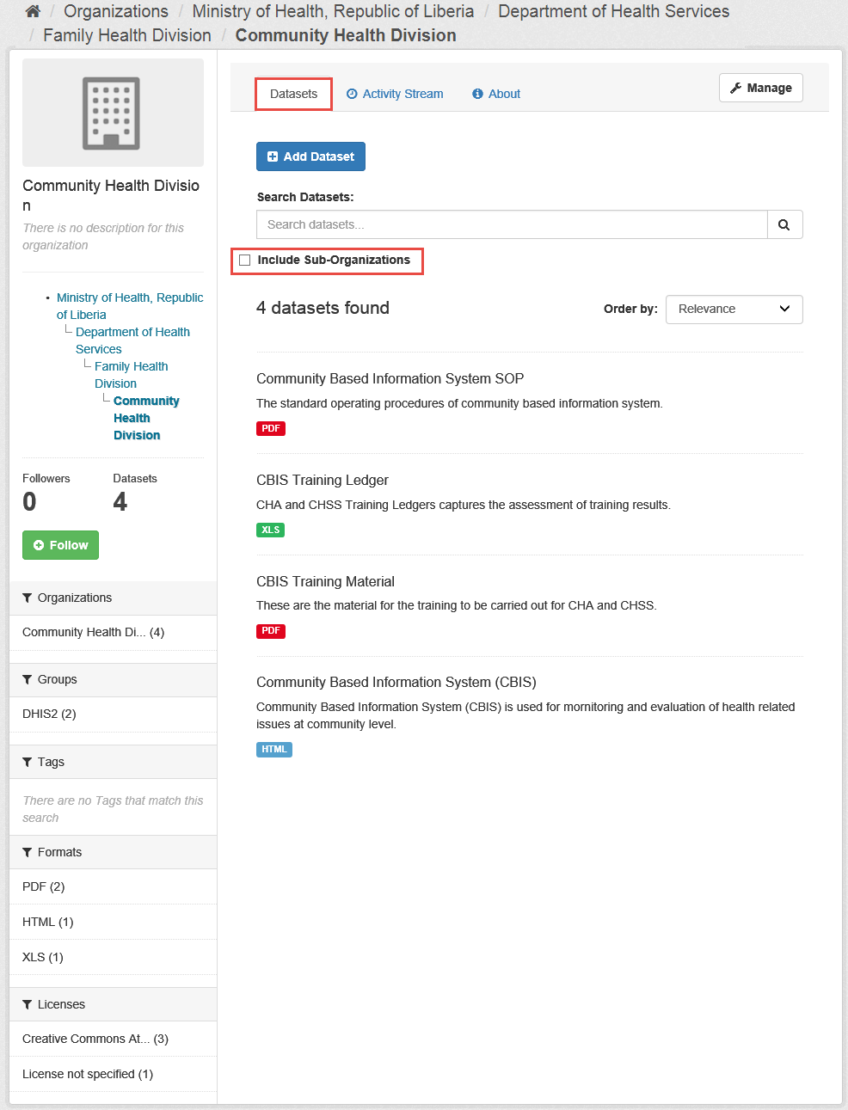

### View Organization - About Tab

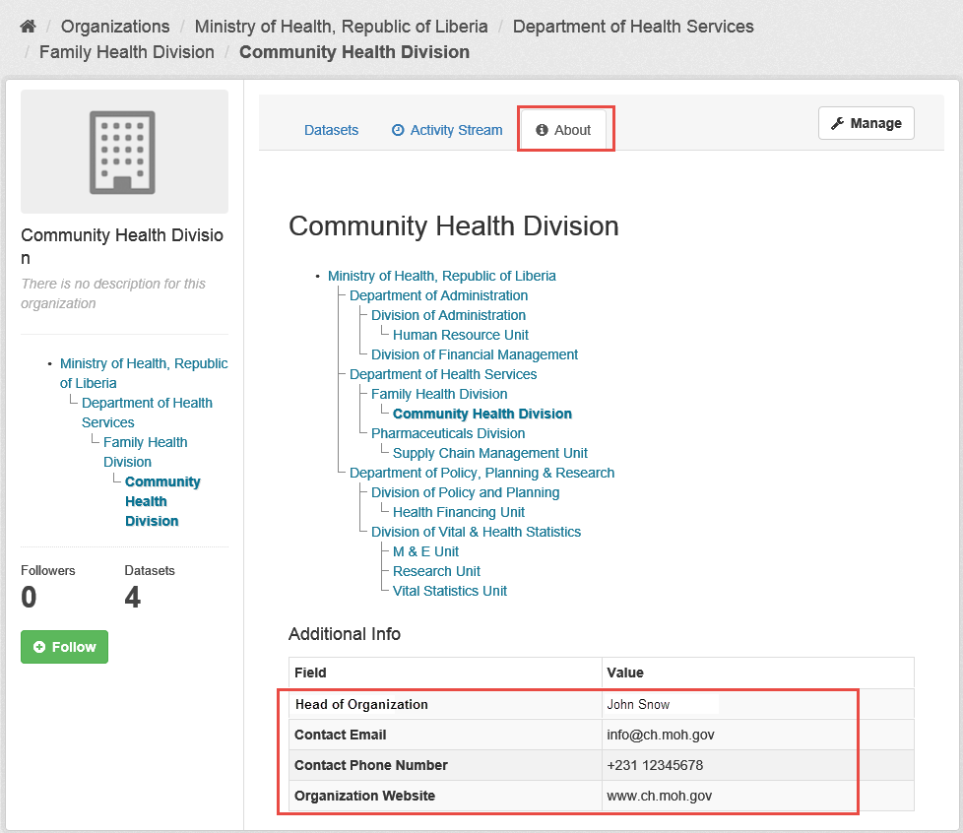

### View Organization - Activity Stream Tab

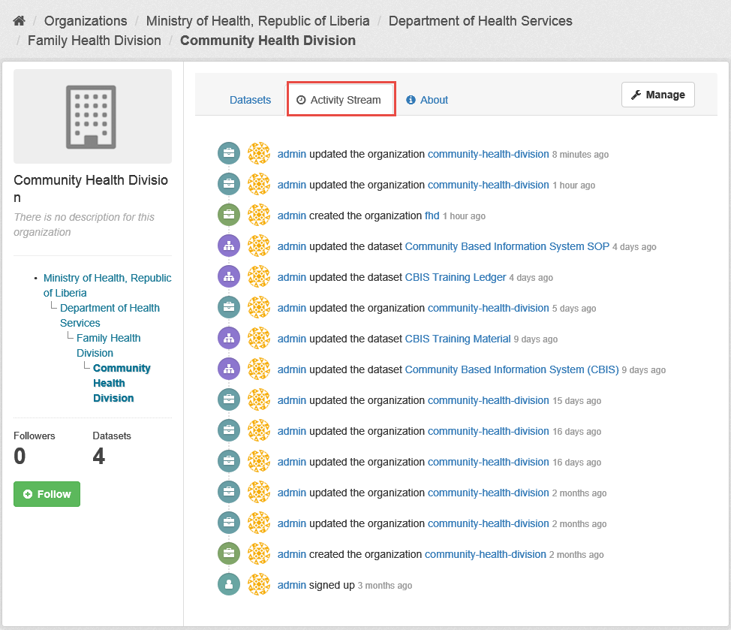

### Create Dataset That is Health Information Subsystem

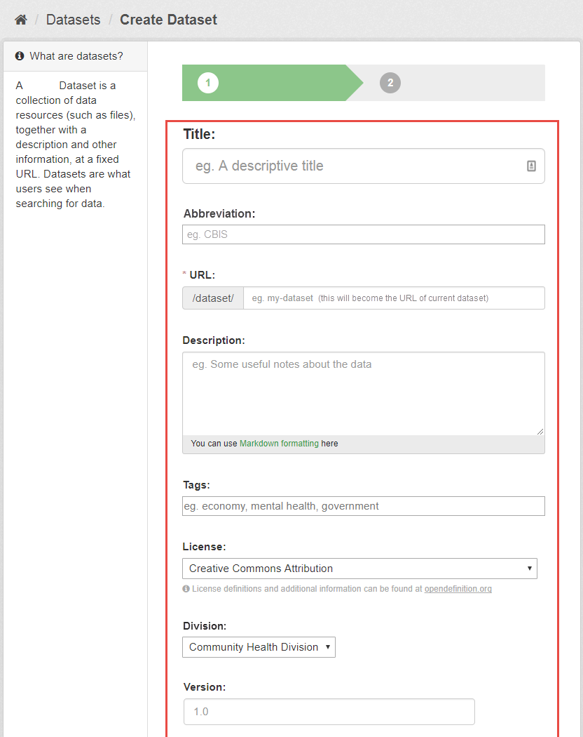

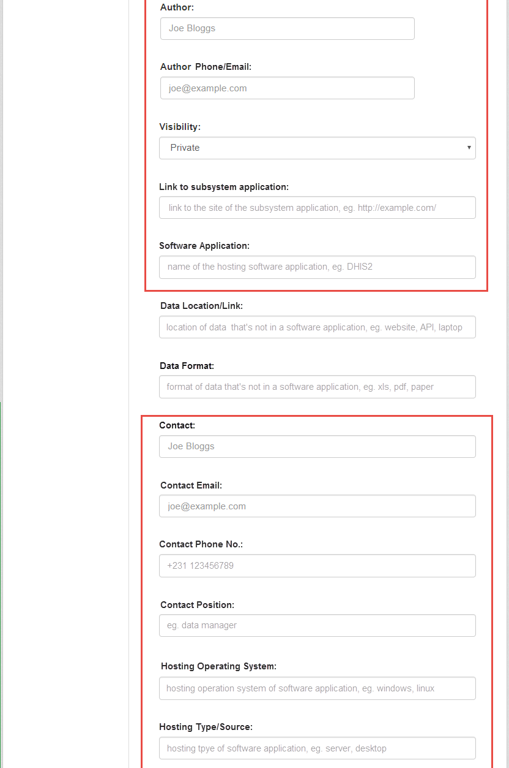

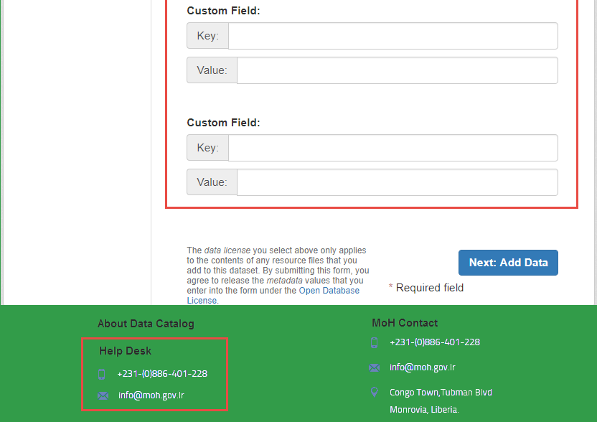

### 

### 

### 

### Create Dataset That is Not Health Information Subsystem

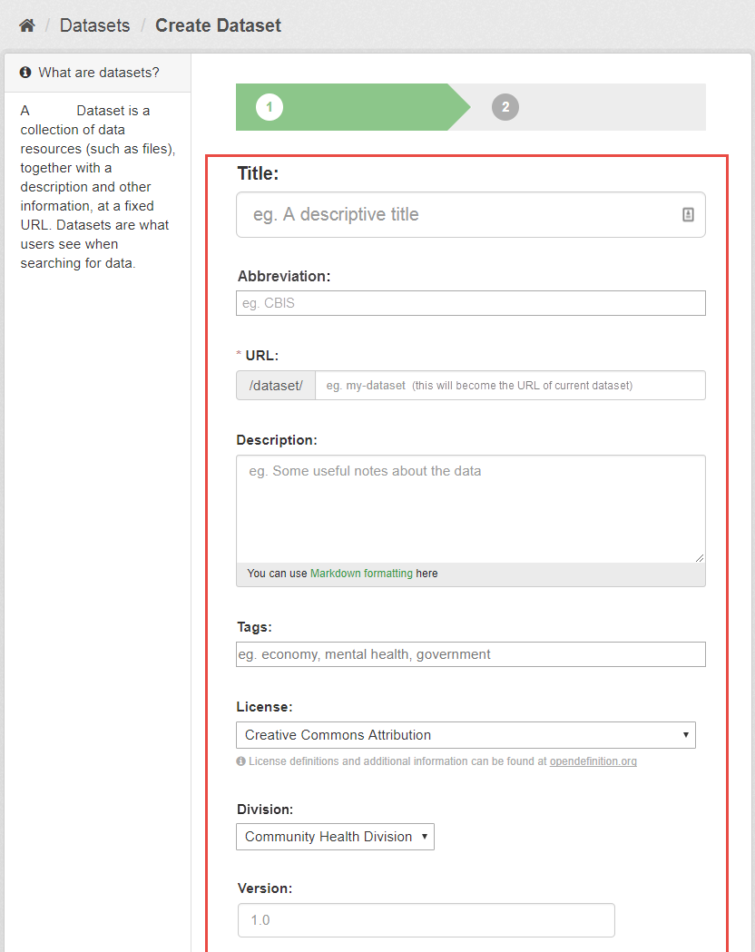

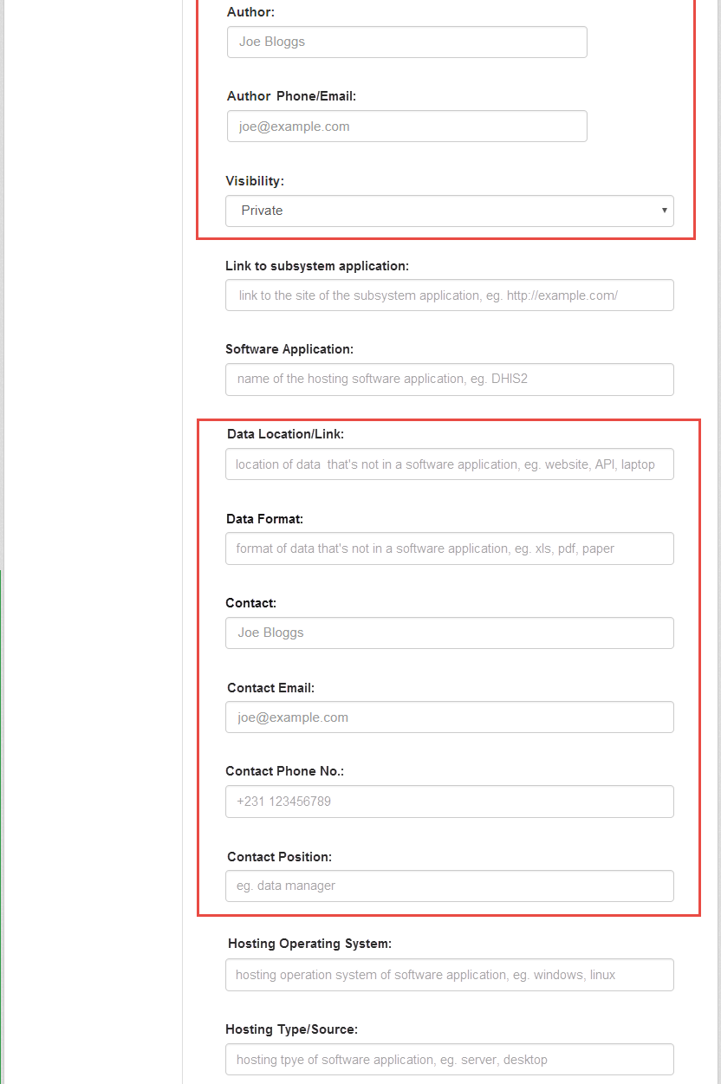

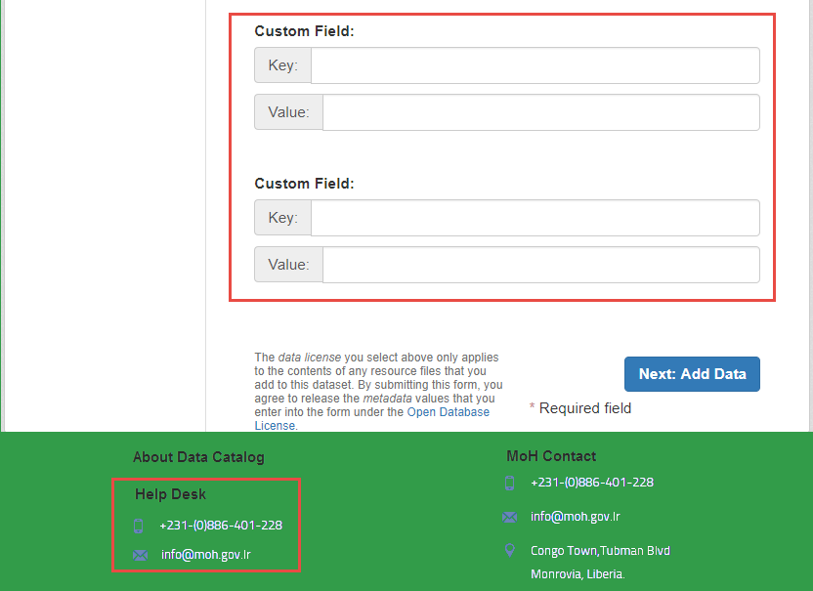

### 

### 

### View Dataset That is HIS Subsystem

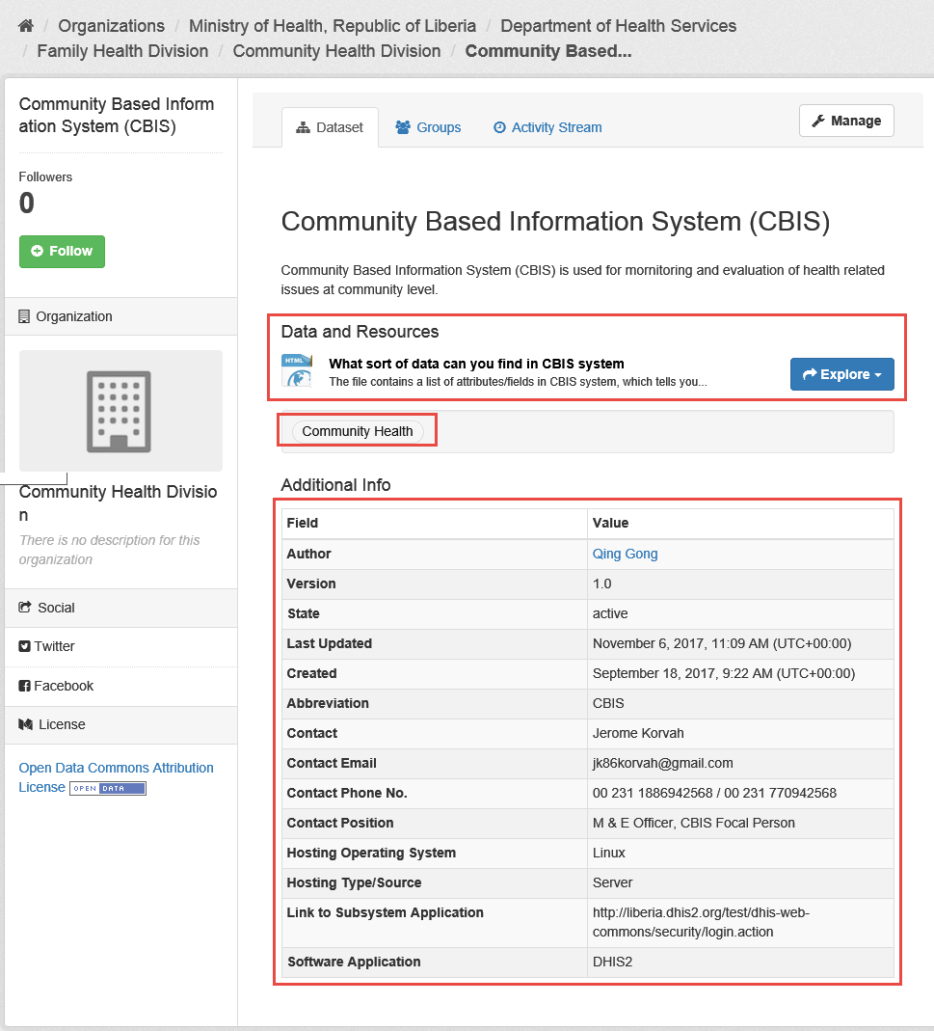

### View Dataset That is Not HIS Subsystem

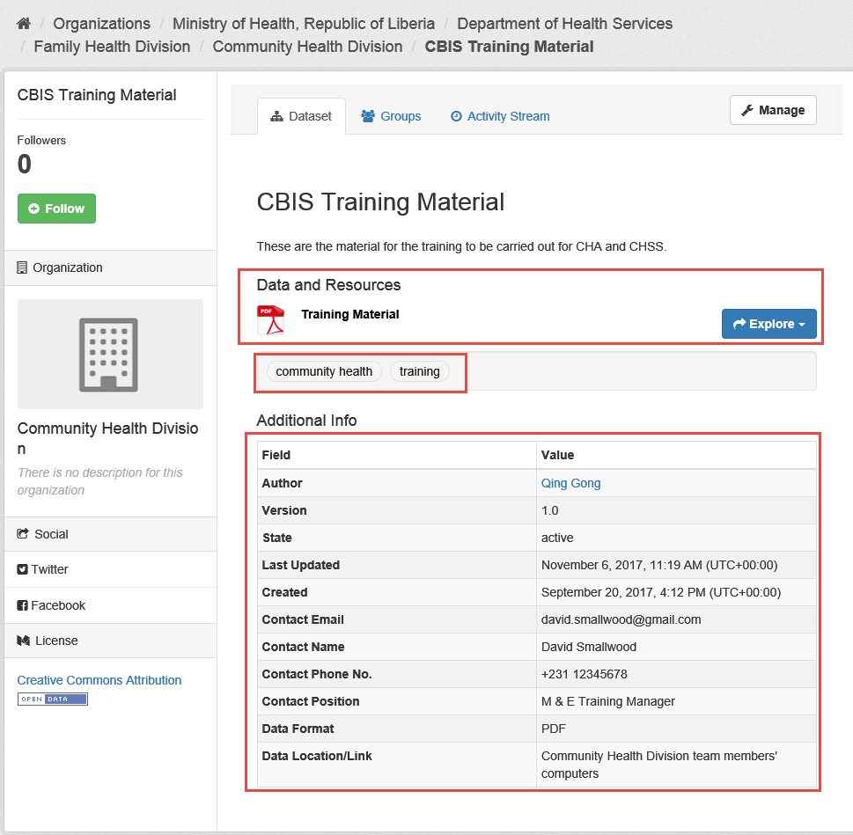

## User Roles and Access Control